H.T No
Regulations:
A18

Sreenidhi Institute of Science and Technology
(An Autonomous Institution)
Code No: 7AC41 Date: 12-Sept-2024 (FN)

B.Tech II-Year I- Semester External Examination, Sept - 2024 (Supplementary)
BASIC ELECTRICAL ENGINEERING (CSE and it)

Time: 3 Hours Max.Marks:70

Note: a) No additional answer sheets will be provided.
b) All sub-parts of a question must be answered at one place only, otherwise it will not be valued.
c) Missing data can be assumed suitably.

Bloom's Cognitive Levels of Learning (BCLL)

Remember | L1 | Apply | L3 | Evaluate | L5
Understand | L2 | Analyze | L4 | Create | L6

Part - A Max.Marks:20
Answer all QUESTIONS

 |  | BCLL | CO(s) | Marks
1 | State superposition theorem. | L1 | CO1 | [2M]
2 | Derive R.M.S value and average value for full wave rectifier. | L3 | CO2 | [2M]
3 | Give the applications of DC motors. | L5 | CO3 | [2M]
4 | What are the different losses present in the transformer? | L2 | CO4 | [2M]
5 | A 50Hz, 8-pole IM has full-load slip of 4%. The rotor resistance and standstill reactance are 0.01Ω and 0.1Ω per phase respectively. Find the ratio of maximum torque to full-load torque. | L5 | CO5 | [2M]
6 | Define Deflecting torque , Control torque and damping Torque | L1 | CO6 | [2M]
7 | What are passive elements? | L1 | CO1 | [2M]
8 | Derive the condition for maximum efficiency of a single phase transformer. | L3 | CO4 | [2M]
9 | What is slip? | L3 | CO5 | [2M]
10 | A Moving Coil Instrument gives a full scale deflection of with a current of 40µA, while the internal resistance of the meter is 500Ω.It is to be used as a voltmeter to measure a voltage range of 0-10V.Calculate the multiplier resistance needed. | L5 | CO6 | [2M]
Part – B Max.Marks:50
ANSWER ANY FIVE QUESTIONS. EACH QUESTION CARRIES 10 MARKS.

 |  |  | BCLL | CO(s) | Marks
11. | a) | Using superposition theorem, find the current in each branch of the network shown in Fig. below  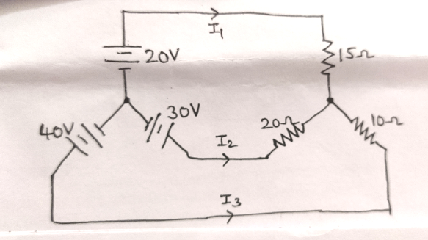 | L2 | CO1 | [5M]
 | b) | Explain about series-parallel circuits. | L5 | CO1 | [5M]
12. | a) | A current wave is given by i=100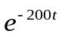.The time period of the wave is 0.05second.Find the average and r.m.s. values of the wave | L5 | CO2 | [5M]
 | b) | Derive the expressions for average value, RMS value, form factor, peak factor of a sinusoidal voltage wave form. | L5 | CO2 | [5M]
13. | a) | Discuss the principle of operation of DC generators. | L2 | CO3 | [5M]
 | b) | Explain the types of DC motors. | L2 | CO3 | [5M]
14. | a) | Explain the working principle of Single Phase Transformer. | L2 | CO4 | [5M]
 | b) | Derive voltage regulation of a single phase transformer for lagging power factor? | L3 | CO4 | [5M]
15. | a) | The power input to the rotor of a 440 V, 50 Hz, 3-phase, 6-pole induction motor is 60kW. It is observed that the rotor emf makes 90 complete cycles per minute. Calculate (i) the slip (ii) the rotor speed (iii) rotor copper loss and (iv) mechanical power developed. | L2 | CO5 | [5M]
 | b) | Discuss about delta connection of three phase circuits. | L2 | CO5 | [5M]
16. | a) | Explain the principle of operation of PMMC instrument. | L2 | CO6 | [5M]
 | b) | With neat diagram explain about Moving Iron repulsion instrument. | L2 | CO6 | [5M]
17. | a) | Explain about Kirchhoff’s laws. | L5 | CO1 | [5M]
 | b) | Discuss about ac circuit containing capacitance. | L5 | CO2 | [5M]
18. | a) | The open circuit and short circuit tests on a 10KVA ,125/250 V ,50Hz single phase transformer gave the following results:  O.C Test :125V,0.6A ,50W(on L.V. Side)  S.C Test :15V,30A,100W(on H.V. Side)  Calculate the regulation at full load ,0.9 leading p.f. | L5 | CO4 | [5M]
 | b) | Derive the torque equation of a three phase induction motor. | L4 | CO5 | [5M]

-- 00 -- 00 –

